- Introduction to Network Devices Theory

Q1. Create a table listing the main functions and typical ports used by switches, routers, hubs, firewalls, and access points in a home WiFi setup?

Answer
- Main Functions and Typical Ports
Network Device | Main Function | Typical Ports
- Switch | Connects multiple devices in a local network and transfers data between them. | Ethernet ports, Console port, Power port
- Router | Connects different networks and provides internet access to devices. | WAN port, LAN Ethernet ports, Console port, Power port
- Hub | Connects multiple devices and sends data to all connected devices. | Ethernet ports, Power port
- Firewall | Protects the network by checking and blocking unwanted or unsafe traffic. | Ethernet/WAN/LAN ports, Console port, Power port
- Access Point (AP) | Provides WiFi connectivity to wireless devices such as phones and laptops. | Ethernet port, Power port, Antenna

Q2. Given images or diagrams of network devices, label each device and mark the ports (Ethernet, console, power, antenna) for at least three devices?

Answer
- Network Devices and Ports

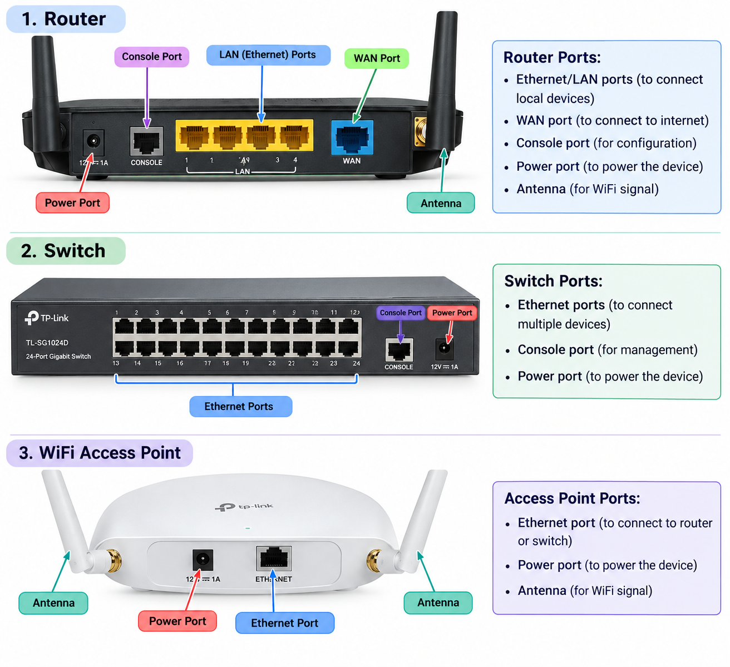

Q3. Pick a popular app you use daily (like Instagram, Zomato, or Paytm) and describe in 3-4 lines how at least two different network devices (from switches, routers, firewalls, access points) play a role when you use that app?

Answer

- Example: Instagram
When I use Instagram, my phone first connects to the WiFi Access Point. The Access Point sends the data to the router, which connects my home network to the Internet. The router forwards my request to Instagram's servers and sends the received data back to my phone. A firewall can also check the network traffic and block unwanted connections.

Q4. Suppose your college WiFi is slow and sometimes disconnects. Based on the features of access points, switches, and routers, suggest one possible reason for the issue and how upgrading one device could help.<br><br><em><strong>Hint:</strong> Think about device capacity, coverage, and traffic handling.</em>?

Answer

- Slow College WiFi

- One possible reason for slow college WiFi is that the Access Point is handling too many users at the same time. This can cause slow speed and frequent disconnections.
- Upgrading the Access Point to a newer and higher-capacity model can support more users, provide better coverage, and handle more network traffic. This can make the college WiFi faster and more stable.

